# Data Sense

The purpose of this project is to develop a Python app, named Data Sense, that can analyze the sales data of an industry stored in a Remote Database. The app provides both visual and numeric analysis of the data and offers a GUI interface for users to access and analyze the data directly from the Remote Database in fraction of time.

## Read CSV File Using Python Panda and Store To DB | Ruby on Rails and Python DjangoLibraries and APIs Used

The app utilizes the following libraries:

* ***Matplotlib*** for creating graphs and visualizations of the data
* ***Pandas*** *for Data Management*



* ***Python Image Library (PIL)*** library for GUI enhancement.
* 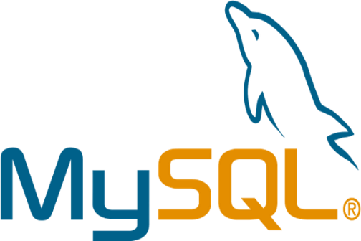***MySQL Connector*** *for managing Database.*



* ***SecuriPy***, a library developed by the app’s developer, for security-related functionalities.

## Features Offered

1. **Accountability** for safe and secure access to big data. The app offers a safe and secure account management system with encrypted credential storage to security.

**Here is a preview of the homepage of the app.**

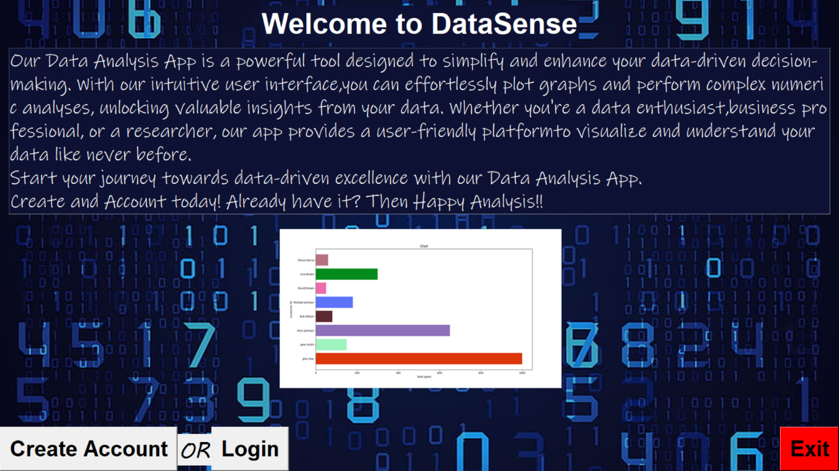

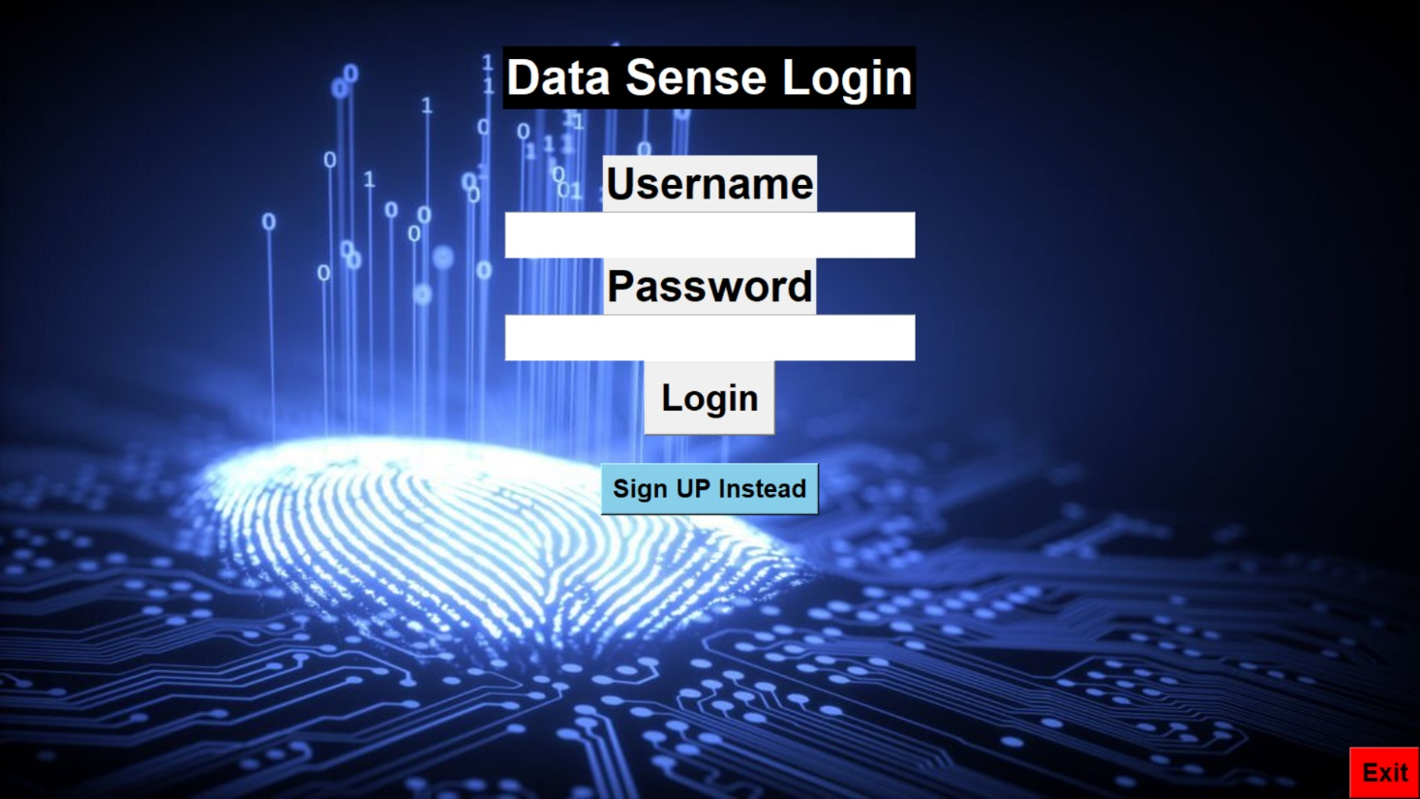**Here is a preview of the login page of the app.**

And,

Here is a preview of the signup page of the app.

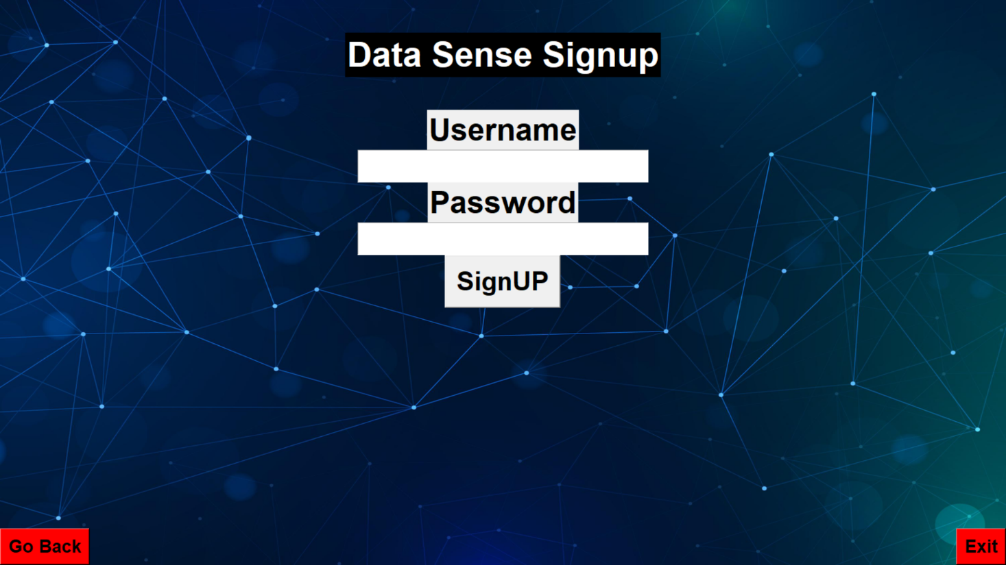

1. **GUI interface** for accessing and analyzing sales data: Users can access the sales data directly from the Remote Database through a GUI interface and choose between visual or numeric analysis of the data.

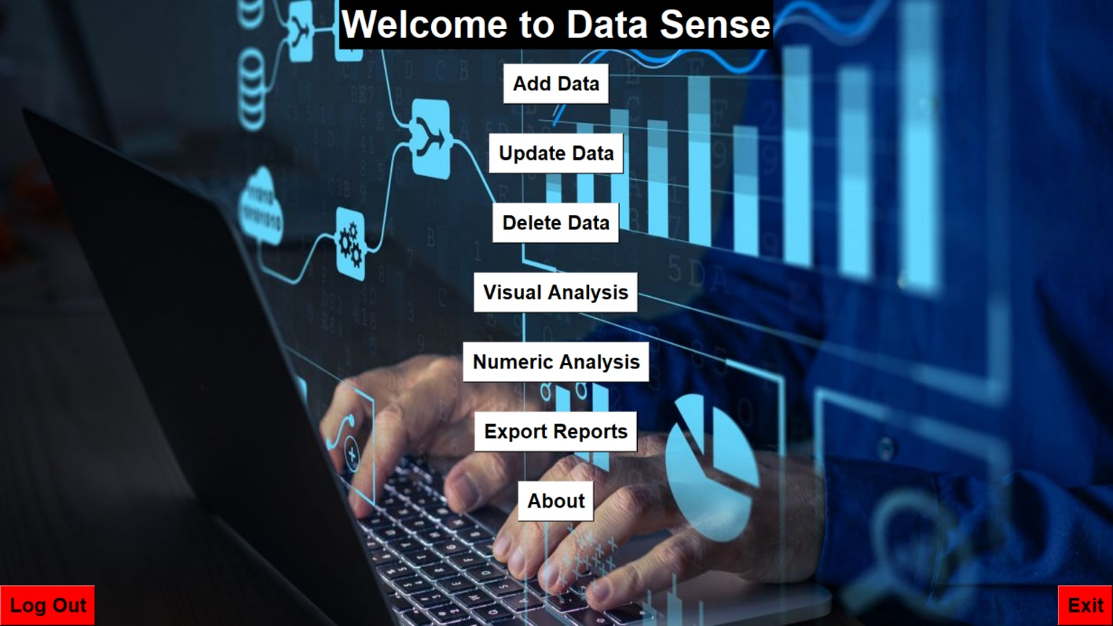

1. **Visual analysis** of sales data: The app uses **Matplotlib** to create graphs and visualizations of the sales data, such as bar charts, histograms, etc., according to the parameters selected by the user.

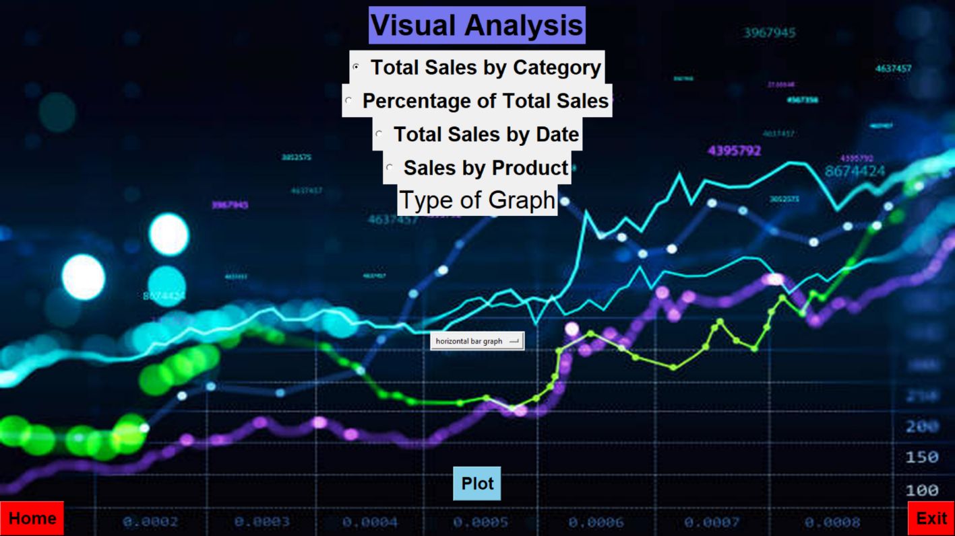

1. **Numeric analysis** of sales data: The app uses **NumPy** to perform numerical analysis of the sales data, such as calculating the mean, median, mode, or standard deviation of the data.

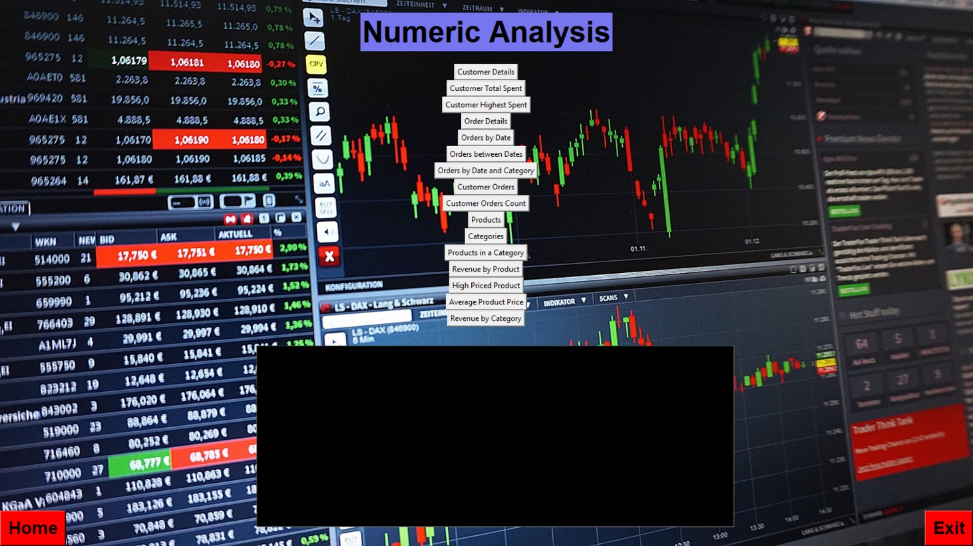

1. **Automated** Suggestions of Analysis: The app is integrated with a system that provide suggestions based on the analysis of the sales data to enhance production and sales.



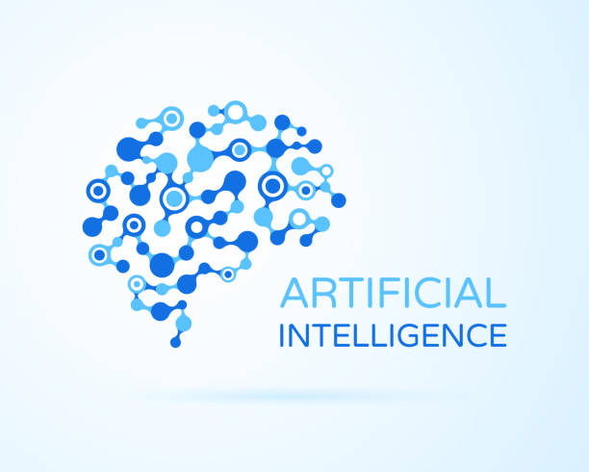

1. **Data export**: The app allows users to export the analyzed data in various formats, such as:
   * Graphs: **JPEG, PNG.**
   * Selected Data: **CSV, ANY SPREADSHEET.**

The expected outcomes may be one of the following:

1. A graph plotted based on the selected parameters.
2. Numeric data corresponding to the analysis performed.
3. Quick suggestions based on the analysis.

Example Visual Output is

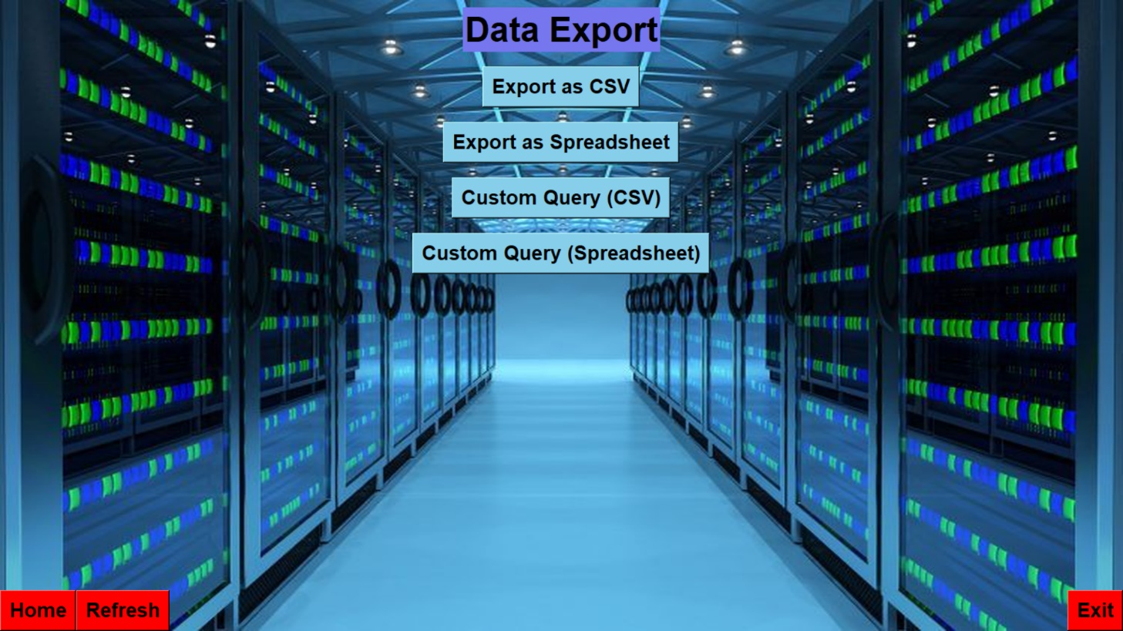

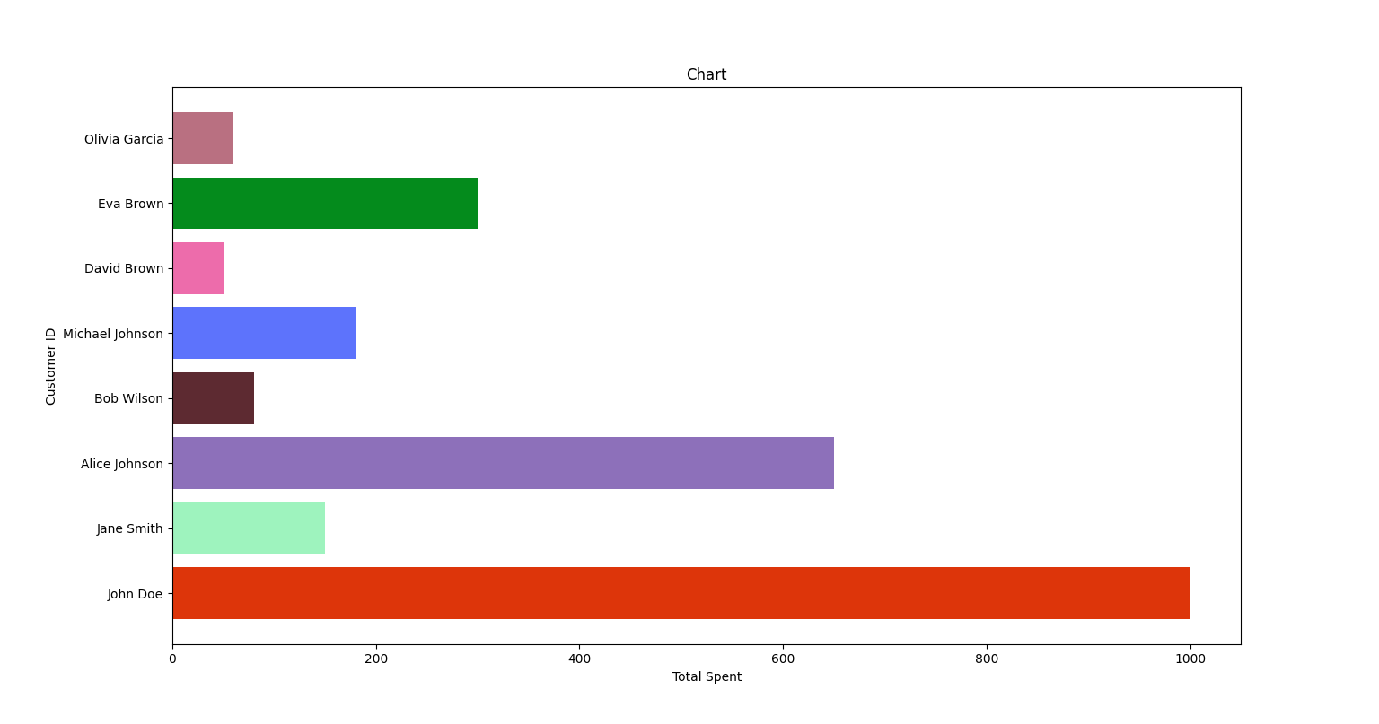

7.  **Data Manipulation:** This app allows users to modify the data stored in the database upon high security authentication

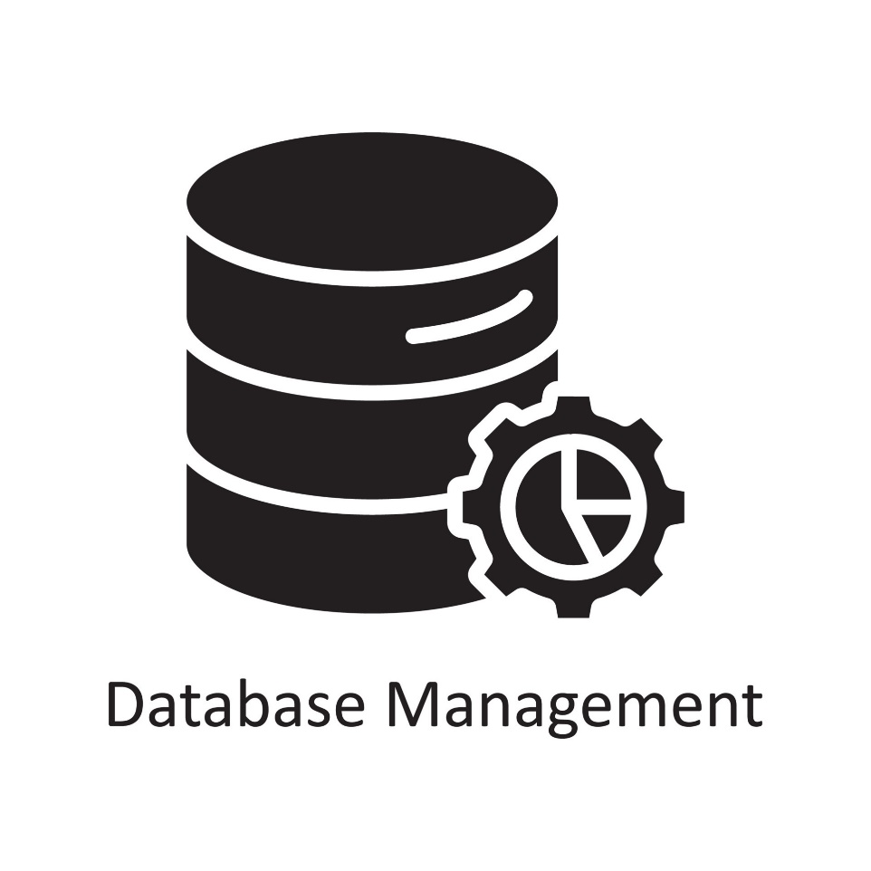

Users can enhance their work culture into the data of their industry with latest future technologies.

Overall, the Data Sense app provides a user-friendly interface for accessing and analysing data stored in their Database and offers a range of analytical tools for visualizing and interpreting the data.

***By Anupam Kanoongo***

***Class 12th D***

***Session : 2023-24***